Advice on inclusion for all schools



Supporting pupils who have a Visual Impairment



Contact us at:

Students Support Service

Castle View Enterprise Academy

Cartwright Road

Sunderland SR5 3DX

Tel: 0191 561 5533

Fax: 0191 548 4417

Co-ordinator: Jill Bowe

**Introduction**

No two students who are assessed as being severely sight impaired (blind) or sight impaired (partially sighted) are identical. Visual Impairment affects each individual in a different way.

This booklet aims to provide possible strategies that may be employed to make individual subjects more accessible to a student with a visual impairment. Additional advice is always available from specialist teachers and support staff, which will address the individual’s needs.

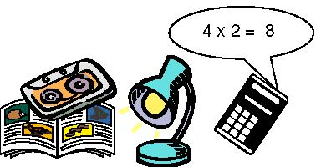

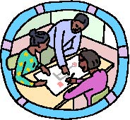

**General**

• Forward planning is essential to enable specialist equipment, resources and modifications to be provided for the VI students, enabling them to have full access to the curriculum.

* VI students should be encouraged to work independently: providing them with the necessary resources facilitates this.



* Desk copies of work shown on the board or interactive whiteboard will give the VI student equal access to the curriculum.
* VI students will need their own copy of shared class books or texts and should never be asked to share.
* Books are often visually complicated and may need enlarging and modifying. Fancy fonts and coloured backgrounds are attractive to a sighted student, but are not helpful for VI students.



* Retrieving information is time-consuming and extra time or support will be needed. The reading speed of VI students is generally slower than that of their sighted peers.
  + - A verbal commentary of what is happening, and what is being written on the board enables the VI student to feel part of the lesson.

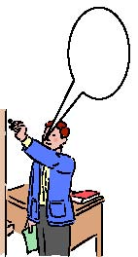

* + - Stationary and hand writing equipment should be provided to suit the individual preferences of the student. A variety of stationary is available.
    - VI students with colour deficiency are likely to experience difficulties, especially with work involving art, maps and diagrams or questions to words in colour
  + The VI student should be encouraged to work independently by making use of their prescribed magnification aids.



**English**

* A preview of information and resources is helpful.
* Conceptual understanding of the subject / vocabulary should be checked.
* Chosen texts may need modifying into a suitable print size and format.
* VI students will need their own copy of shared class books.
* The development of reading and spelling skills may be different for VI students who lack incidental exposure to words in the same way as their fully sighted peers: extra input is often needed to develop fluency and speed of reading.
* Real objects and experiences may be required for younger students.
* 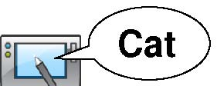Large print copies of many books, and dictionaries or talking dictionaries are available. Some tactile books are available.

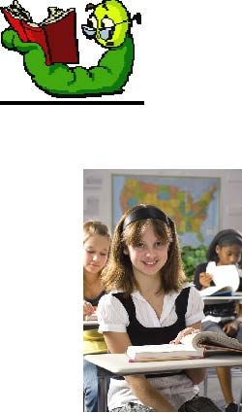

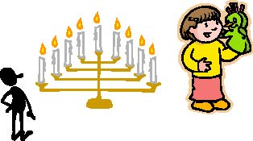



* Handwriting may need to be modified to suit VI students. They may prefer to use a simple linked style of handwriting rather than a fancy cursive script. It is important that they can read back their own writing
* Retrieving information is time consuming for the VI student who may need help in locating relevant text.

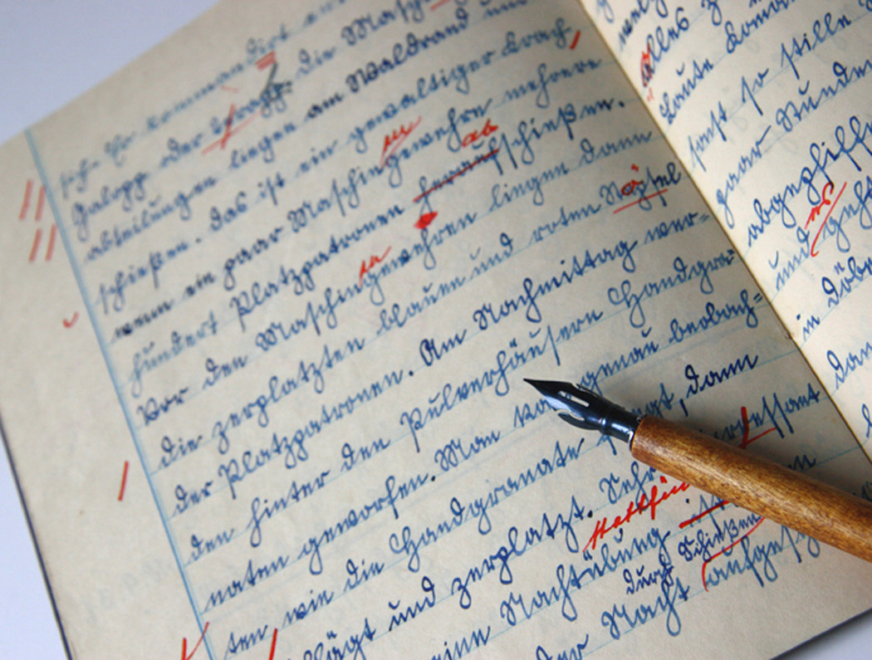

* Strategies for answering questions about a text may be different and the VI student is often encouraged to read the questions before the text.

**Mathematics**

* A variety of strategies may be required to convey an idea.
* VI students will benefit from "concrete" practical learning opportunities.



* Tactile exploration of shape, length etc may be beneficial.
* The VI student will require their own personal copies of class resources, such as 100 squares, timetables, number lines etc.



* Specialist graph paper, large display or talking calculators, and a wide range of specialist equipment is available.

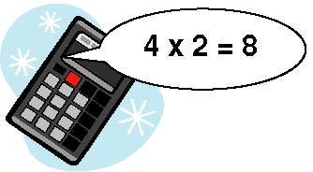

* VI students are entitled to extra time in examinations to enable them to complete a task. In class they may be instructed to complete alternate or alternative question. Many VI students have good mental maths skills, which they should be encouraged to utilise.



* Methods of setting out calculations may be modified or simplified to suit the VI student (who may find scanning and retrieving information difficult).



* + - VI students are granted a tolerance with the accuracy of measurement e.g. 5 degrees with protractors.



* VI students should use real money.
* Extra time is needed for mental maths recording.





**Science**

* Support is essential for any task where safety is an issue.
* Allow VI students to handle material and equipment prior to the start of any experiments.



* Allow the VI student to sit in the best viewing position when demonstrating experiments and verbalise the process.
* Provide unscratched safety goggles.
* Give VI students their own tray of equipment.

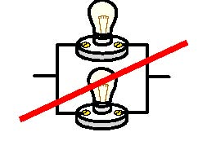



* Add colour to clear liquids to enable easier measuring.
* Syringes are useful when measuring liquids.
* Buzzers should be used instead of bulbs in experiments involving circuits.
* Add dark tape to glassware to make visible marking.

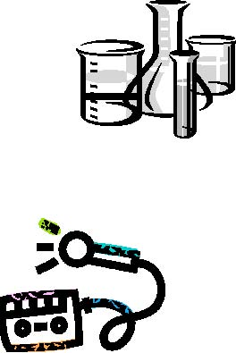

* Use measuring equipment with large clear numbering
* Provide specialist graph paper
* Use large clear labels on apparatus
* Use talking equipment where appropriate



**Music**



* VI Students may need extra time to learn and familiarise themselves with complex instruments e.g. keyboards.
* Provide hands on experience of instruments.
* Positioning of individual copies is important.
* Record music to help learning.



* + - Musical notation may need modification.
* Music stands may need to be adapted to fit on the wall for optimum angle of access



**Art**

* 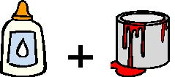Allow the VI young person extra time and opportunity to closely inspect and examine any pictures or fabrics.
* Tactile, 3D tasks may be most appropriate for some VI students.
* Coloured glue sticks allow the VI student to see where the glue is.
* PVA coloured with paint gives a tactile painting experience.
* Scented marker pens help to reinforce and differentiate colours.
* An activity may be modified to make it more meaningful to a VI student.

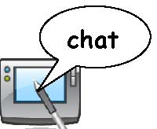

**Languages**

* The VI student may need opportunities to see new words or texts in advance.
* Large print and talking dictionaries are available.
* The VI students may need their own flashcards and copies of vocabulary displayed around the room.
* Laptop computers are useful but symbols for accents need to be taught
* Trips require good preparation and support to enable VI students with visual impairment to participate safely.

**Technology** 

* Safety should be considered: a clutter­free space will assist in this.
* Additional supervision for safety may be necessary.
* Extra time may be required to investigate, practise skills and familiarise with equipment.
* The choice of appropriate tasks is important.
* Specialist equipment is available such as needle threaders, or talking scales
* Equipment will need storing neatly and consistently.
* Check accessibility of dials etc. on equipment. Tactile markers can be added.

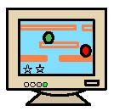



**I.C.T.**

* Large monitors may be sufficient for many VI students to access computers.
* Settings can be altered to provide extra contrast, large icons, text and pointers.
* Specialist magnification software can enlarge anything that is on the screen.



* Screen reader software can be used to enable the VI students to read the screen.
* VI students can learn "hot keys" and short cuts to reduce the use of the mouse. Clearly contrasted keyboards are beneficial.



* + - Touch-typing skills should be taught to reduce the need to look at the keys.
    - The position of the monitor and height of seating should allow close viewing at eye level.
    - Background and foreground colour can be changed.
    - Antiglare screens may be useful.



**History Geography RE**

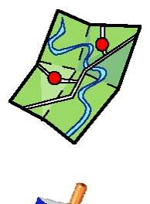

* Extra time and opportunities to investigate source materials are important.
* Original photographs, maps etc are clearer than photocopies.
* 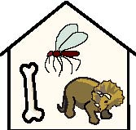Real objects can aid understanding



* Visits and field trips allow experiential learning, but require good planning and possibly support. Negotiate with museums to handle objects.
* Maps cause difficulties and may need to be simplified.
* Separate maps may be required for different information e.g. one for rivers, one for towns etc.



* Consider colour vision in the use of keys.
* Hatching (shading with pattern) or different textures may be required.
* Tactile globes and templates are available as are large print atlases.
* 3D models may aid understanding.
* Large print Bibles are available.

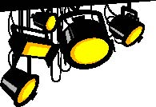



**Drama**

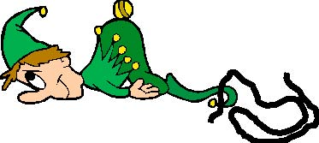

* VI students often find difficulty in interpreting non-verbal cues such as gestures, facial expressions, and body language.
* Many VI students are sensitive to bright light and changes in lighting: lighting issues such as glare, dark areas and changes of lighting may cause difficulty.
* Background noise and movement might be disorientating and confusing.
* The VI students will require time to familiarise
* themselves with the room/stage.
  + - Consider safety issues around cables, edge of stages etc.

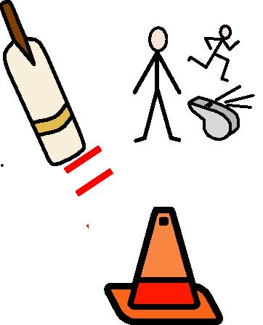

**P.E.**

* Larger, brightly coloured equipment is beneficial.
* Bright tape can be used to mark edges of apparatus.
* Cones can be used to mark the edge of pitches.
* Allow time to feel or examine apparatus.
* Consider safety in team games - some may not be appropriate for a specific student.
* Individual instruction is important.
* Personal challenges or skill drills may be more appropriate than team games.
* Allow the young person more space to move.
* The child may need to wear glasses for P.E., Games and Swimming (prescription goggles can be prescribed by the ophthalmologist).



* VI students may need more time at the beginning and end of lesson for independent changing.
* Guides may be necessary for running
* For ideas on strategies for games consult the VI support staff.
* Audible equipment is available

**Educational Trips**

When planning educational trips you will need to consider the following:

* Have you done a risk assessment with the child's visual difficulties in mind?
* Will it be beneficial to contact the venue to arrange better access?
* Is additional support required for safety and/or educational reasons?