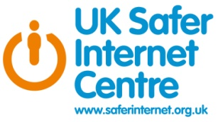
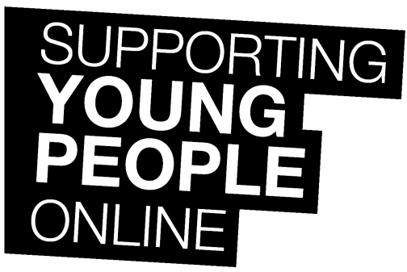

January 2015
Dear Parents and Carers
February 10th 2015 is Safer Internet Day, a day that is very important to our Academy and students. Safer Internet Day is run by the INSAFE network and is celebrated every year across Europe, and in other countries worldwide.
In the UK, Safer Internet Day is organised by the UK Safer Internet Centre (www.saferinternet.org.uk), and this year’s theme is “Let’s create a better internet together.” Childnet International, who form part of the UK Safer Internet Centre, have produced a set of resources to help parents and carers to support children and young people online. Please find enclosed with this letter their guidance on supporting young people online.
We believe that internet safety education is a crucial element of the curriculum and an essential part of young people’s development. To celebrate the many positives of the internet, and to raise awareness of the issues that children and young people face online today, our students will be participating in a range of events to celebrate Safer Internet Day and to learn more about staying safe online. More information on these events and further advice on e-safety can be found on our Academy website (www.castleviewenterpriseacademy.co.uk).
Yours sincerely
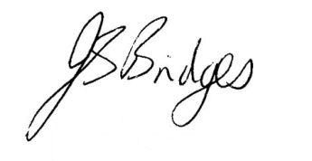
Mrs J S Bridges OBE
Principal

